**MAHESHWARAN A**

**IT - B**

**CC – 1**

**Task – 1**

package PACKAGE;

import org.openqa.selenium.By;

import org.openqa.selenium.WebDriver;

import org.openqa.selenium.chrome.ChromeDriver;

import org.openqa.selenium.chrome.ChromeOptions;

//import org.testng.Assert;

import io.github.bonigarcia.wdm.WebDriverManager;

//import org.testng.annotations.Test;

public class question1 {

public static void main(String[] args) {

WebDriverManager.chromedriver().setup();

WebDriver driver;

ChromeOptions co = new ChromeOptions();

co.addArguments("--remote-allow-origins=*");

driver = new ChromeDriver(co);

driver.get("https://www.saucedemo.com/");

driver.get("https://www.saucedemo.com/");

driver.findElement(By.xpath("//*[@id=\"user-name\"]")).sendKeys("standard_user");

driver.findElement(By.xpath("//*[@id=\"password\"]")).sendKeys("secret_sauce");

driver.findElement(By.xpath("//*[@id=\"login-button\"]")).click();

System.out.println("login successfullly");

driver.findElement(By.xpath("//*[@id=\"add-to-cart-sauce-labs-backpack\"]")).click();

driver.findElement(By.xpath("//*[@class=\"shopping_cart_link\"]")).click();

System.out.println(" added to cart");

driver.findElement(By.xpath("//*[@id=\"checkout\"]")).click();

System.out.println("Redirected to the Your information page");

driver.findElement(By.xpath("//*[@id=\"first-name\"]")).sendKeys("MAHESHWARAN");

driver.findElement(By.xpath("//*[@id=\"last-name\"]")).sendKeys("A");

driver.findElement(By.xpath("//*[@id=\"postal-code\"]")).sendKeys("635203");

driver.findElement(By.id("continue")).click();

String title="Swag Labs";

String actual=driver.getTitle();

if(title.equals(actual)) {

System.out.println("verified the title");

}

else {

System.out.println("Not verified the title");

}

String url="https://www.saucedemo.com/checkout-step-two.html";

String current=driver.getCurrentUrl();

System.out.println(current);

if(url.equals(current)) {

System.out.println("verified the url");

}

else {

System.out.println("Not verified the url");

}

}

}

**Output :**

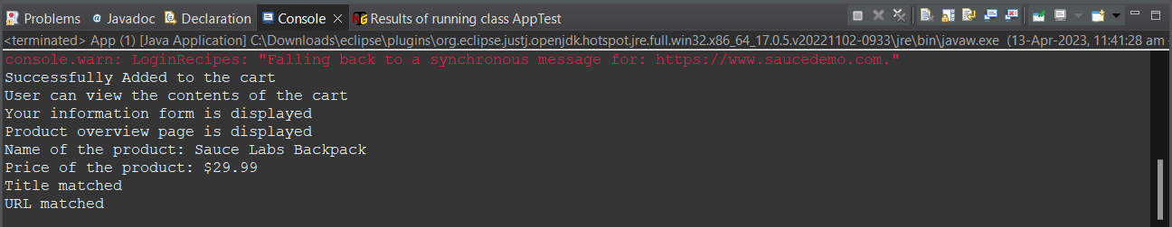

**Task – 2**

package com.demo.Demo;

import org.openqa.selenium.By;

import org.openqa.selenium.WebDriver;

import org.openqa.selenium.WebElement;

import org.openqa.selenium.firefox.FirefoxDriver;

import org.openqa.selenium.support.ui.Select;

import io.github.bonigarcia.wdm.WebDriverManager;

public class task2 {

public static void main( String[] args ) throws InterruptedException

{

WebDriverManager.*firefoxdriver*().setup();

WebDriver driver = new FirefoxDriver();

driver.manage().window().maximize();

driver.navigate().to("https://www.saucedemo.com/");

driver.manage().window().maximize();

WebElement txtBoxl=driver.findElement(By.*xpath*("//*[@id=\"user-name\"]"));

txtBoxl.sendKeys("standard_user");

WebElement txtBox2=driver.findElement(By.*xpath*("//*[@id=\"password\"]"));

txtBox2.sendKeys("secret_sauce");

driver.findElement(By.*xpath*("//*[@id=\"login-button\"]")).click();

String txt1=driver.findElement(By.*xpath*("//*[@id=\"item_4_title_link\"]/div")).getText();

System.***out***.println(txt1);

driver.findElement(By.*xpath*("//*[@id=\"header_container\"]/div[2]/div/span/select")).click();

driver.findElement(By.*xpath*("//*[@id=\"header_container\"]/div[2]/div/span/select/option[2]")).click();

String txt2=driver.findElement(By.*xpath*("//*[@id=\"item_3_title_link\"]/div")).getText();

System.***out***.println(txt2);

driver.findElement(By.*xpath*("//*[@id=\"header_container\"]/div[2]/div/span/select")).click();

driver.findElement(By.*xpath*("//*[@id=\"header_container\"]/div[2]/div/span/select/option[3]")).click();

String txt3=driver.findElement(By.*xpath*("//*[@id=\"item_2_title_link\"]/div")).getText();

System.***out***.println(txt3);

driver.findElement(By.*xpath*("//*[@id=\"header_container\"]/div[2]/div/span/select")).click();

driver.findElement(By.*xpath*("//*[@id=\"header_container\"]/div[2]/div/span/select/option[4]")).click();

String txt4=driver.findElement(By.*xpath*("//*[@id=\"item_5_title_link\"]/div")).getText();

System.***out***.println(txt4);

Thread.*sleep*(5000);

}

}

**Output:**

